Qualcomm online test questions

Aptitude and logical resoning topic

Example questions
Q1.
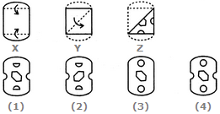

Q 2 to 5 : linked questions (3 questions )

Q6. dirctions
Q7. a man travls north side 36km and take right and traval for 24km and he take left for 12km then he travals towords right 18km and again he traval towords southside 24km.

Q8. how many are correct
55514111145 != 55511411145
55544111451 < 55451114515
54541115415 > 54541145415
Q9. NATION : ANTINO :: HUNGRY : ?

Q10. he Fourth Amendment to the Constitution protects citizens against unreasonable searches and seizures. No search of a person's home or personal effects may be conducted without a written search warrant issued on probable cause. This means that a neutral judge must approve the factual basis justifying a search before it can be conducted.

In the above phargraph how many time “o” will be appeared immediate followed by “a”.

C , CPP , OS topics

- threads , kernel threads
- proccess and resources related questions ( max questions)

- pointers
- Operator Precedence questions (max questions)

- inheritance , polymorphism questions

